**Fatima Shafique**

**SU92 BSAIM S24 – 036**

**TASK 5**

**DFS :**

The code performs a depth-first search (DFS) on a graph, using a stack to explore nodes from a starting point and keeping track of visited nodes to generate a traversal order.

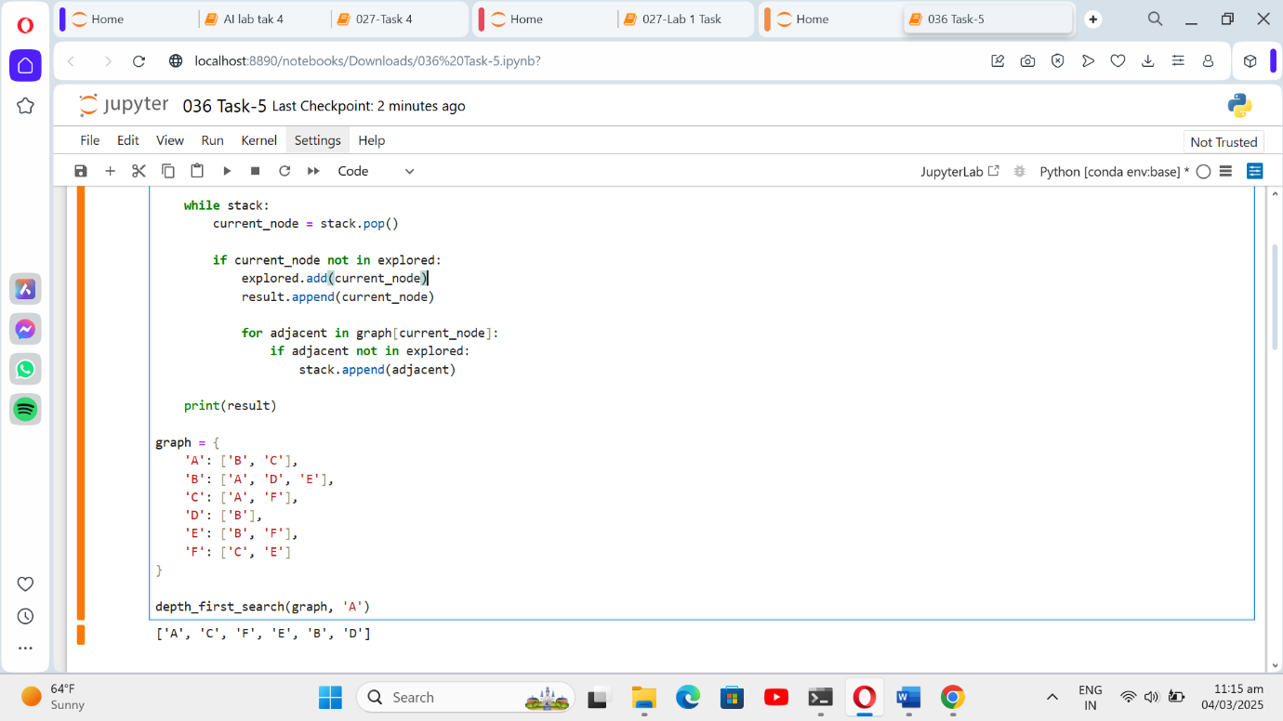

**Traversal :**